Please use the following folder structure for the final assignment:

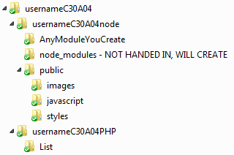

In usernameC30A04 include two folders usernameC30A04node and usernameC30A04PHP.

In usernameC30A04 include:

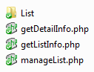

You may also include any common functions in an include file if you wish. If you are using one, the include file should must be called phpInclude.inc.

You may also include any PHP classes in separate PHP files. These should be named by their class name in upper case, as in Person.php

In folder List include file SantaList.xml or SantaList.json.

In usernameC30A04node include:

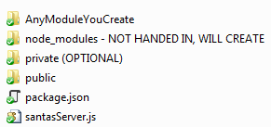

package.json must contain npm dependencies required by your server and ONLY npm dependencies required.

santaServer.js is the name of your node js server that is doing the work.

The node_modules folder will be created when I do an npm install and must NOT be included in what is handed in.

Any node modules you create should be named appropriately and in their own folder with their own index.js and package.json. As these are, essentially, classes, the folder should be named with a capital letter as in Person.

If you are using

The public folder structure will be:

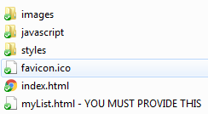

I will provide files in the images and styles as well as the favicon.ico and index.html. You will provide myList.html and you will provide any JavaScript files in the javascript folder and any CSS in the styles folder and any images in the images folder.

If you are using a templating module like pug or mustache store your templates in the private folder. If you are using error messages (and you REALLY should) store them in the private folder. The private folder is completely optional and does not need to be included.